Chapter 1

**INTRODUCTION**

**INTRODUCTION**

* It is widely acknowledged that, high-resolution videos are more and more commonly seen within a great number of visual applications at the current stage. For instance, in video surveillance, multiple high-resolution cameras are necessary to be placed at different locations. They work together to identify and track the moving target making the later high-level analyses based on the moving target (e.g., behavior or even potential intention) more feasible. In emotional computation, high-resolution cameras need to be utilized to capture both obvious and fine changes of emotions of the target person in real-time which has significant impacts in security issues nowadays It is easy to perceive from the above descriptions that, acquiring and storing a large volume of high-resolution videos are often not difficult to be realized for the time being. However,
* the main challenge resides in how to efficiently and effectively make correct high-level decisions based on those low-level video clips of large volumes. In this study, high-resolution videos of drivers recorded within vehicles are emphasized. The high-level decision here is to correctly detect abnormal driving behavior (i.e., patterns) of drivers.Automatic abnormal driving behavior detection is generally accepted as the first issue in realizing the popular fully autonomous driving task.It is certain that,for theautonomous driving task, safety issues are undoubtedly first priorities. It is widely known that, behavior of drivers need to be well restricted in order to avoid any potential accident. Therefore, multiple high-resolution cameras equipped with in the driver’s vehicle can be utilized to monitor the driver’s status in real time. Generally speaking, videos captured by high-resolution cameras also need to be processed immediately, in order to determine whether the current status of the driver is normal or not. It can be acknowledged from the above descriptions that, both the effectiveness (i.e., the detection accuracy) and the efficiency (i.e., the detection speed) of abnormal driving behavior detection are highly demanded. Also, high-speed wireless transmissions are necessary to realize the swift and reliable transmission of high-quality videos, which further facilitates the above automatic abnormal driving behavior detection task [9]– [23].

In order to detect abnormal behavior of drivers, an official and precise definition of abnormal driving is often necessary. According to the International Organization for Standardization (ISO), abnormal driving is defined as the phenomenon that a driver’s ability to drive is impaired due to her / his own focus on other activities unrelated to normal driving.

Chapter 2

**ABSTRACT**

Video-based abnormal driving behavior detection is becoming more and more popular for the time being, as it is highly important in ensuring safeties of drivers and passengers in the vehicle, and it is an essential step in realizing automatic driving at the current stage. Thanks to recent developments in deep learning techniques, this challenging detection task can be largely facilitated via the prominent generalization capability of sophisticated deep learning models as well as large volumes of video clips which are indispensable for thoroughly training these data-driven deep learning models.

deep learning fusion techniques are emphasized, and three novel deep learning-based fusion models inspired by the recently proposed and popular densely connected convolutional network (DenseNet) are introduced, to fulfill the video-based abnormal driving behavior detection task for the first time.

**EXISTING SYSTEM :-**

* abnormal driving detection and deep learning techniques, which are closely related to this study, are emphasized. Recent developments in the two aspects are briefly reviewed, with pros and cons been discussed.
* can be summarized based on literatures of automatic abnormal driving behavior detection that, there are often three commonly used detection schemes.
* The first one is based on the detection of human physiological signals (i.e., electrooculogram, electro-encephalogram, respiratory, blood flow changes, etc.) using diverse kinds of sensors [27], [28]. The second one is based on facial details [29] (i.e., changes in eye movement, mouth movement, head movement, hand features, etc.).
* deep learning techniques receive vast popularity when powerful computational hardware and large-scale data become more and more available nowadays.
* Generally speaking, most contemporary deep learning models can be categorized into two types, i.e., deep generative learning models and deep discriminant learning models. To be specific, deep generative learning models mainly aim to replicate ‘‘fake-but-realistic’’ data based on real data, and popular deep generative learning models include but not limited to VAE (i.e., variational auto-encoder) [34], GAN (i.e., generative adversarial network) [35], GLOW (i.e., generative flow)

**PROPOSED SYSTEM :-**

* proposed deep learning-based fusion models in automatically detecting abnormal driving behavior of this study, the Kaggle state farm distracted driver detection database
* demonstrates the trend of accuracies increasing with respect of training epochs in all compared deep learning models. First, it can be noticed that, accuracies of all deep learning models keep on increasing and then become stable when their training epochs further increase, which is a significant indicator of the thorough training and convergence of all deep learningmodels.Second,threedeeplearning-basedfusionmodels, DenseNet, as well as ResNet outperform other conventional CNN-based models (i.e., CNN, Wide CNN, Group CNN) as revealed in Figure 9. For comparisons between three deep learning-based fusion models and DenseNet, it is interesting to notice that, the former reaches the stable stage faster ( i.e., less epochs) than DenseNet, and significant robustness can be obtained from new deep learning-based fusion models.

**ADVANTAGES OF PROPOSED SYSTEM:**

* main advantage of affecting drivers’ normal drivings cannot be neglected, either. Furthermore, physiological signals of human beings vary greatly due to the physiological difference in each individual person and her / his environmental conditions.

**SOFTWARE REQUIREMENT SPECIFICATION**

**User Requirements**

Requirement Specification plays an important role to create quality software solution. Requirements are refined and analysed to assess the clarity. Requirements are represented in a manner that ultimately leads to successful software implementation.

**Software Requirements**

The software requirements specification is produced at the end of the analysis task. Software requirement is a difficult task, For developing the Application

1. Python

* Technologies and Languages used to Develop

-- Python

**Hardware Requirements**

This is an project so hardware plays an important role. Selection of hardware also plays an important role in existence and performance of any software. The size and capacity are main requirements.

* Operating System supported by

1. Windows

* Processor – Pentium IV or higher
* RAM -- 2 GB
* Space on Hard Disk -- Minimum 10 GB

**Module Description:-**

1. **Generate & Load AWGRD Model:**

Using this module AWGRD train model will be generated from input images download from Kaggle state farm distracted driver detection database. This database contains 22424 images and model is built by using all those images.

1. **Upload Video:**

using this module we can upload video to this application and then start playing video using Python OPENCV library.

1. **Start Behaviour Monitoring:**

Using this module we will extract each frame from video and then resize image according to AWGRD Model. AWGRD Model will be applied on this frame to predict behaviour of driving person. All behaviours will be displayed on playing video.

**issues author has describe 3 algorithms based on CNN deep learning models.**

1. **Wide Group Densely (WGD) Network:** Technically, WGD takes important issues of deep learning models, i.e., the depth, the width and the cardinality, into consideration when designing its model structure based on Dense Net. This model use deep features from input train model to get better prediction accuracy.
2. **Wide Group Residual Densely (WGRD) Network**: The most significant change of WGRD with respect to WGD is that, the idea of residual networks is incorporated in WGRD. In this algorithm input image will pass from one layer to other residual layer to have best features from train input image to get best accuracy.
3. **Alternative Wide Group Residual Densely (AWGRD) Network**: This algorithm works similar to above two algorithms but while passing input data from one layer to other, this algorithm will take super positions of previous layers which has best features from all layer and will have better prediction accuracy. Due to super positions extraction training efficiency will undoubtedly become higher.

Chapter 4

**DESIGN**

**INTRODUCTION**

Software design sites at the technical kernel of the software engineering process and is applied regardless of the development paradigm and the area of application. Design is the first step in the development phase for any engineered product or system. The designer’s goal is to produce a model or representation of an entity that will later be built. Beginning, once system requirements have been specified and analysed, system design is the first of the three technical activities – design, code and test that is required to build and verify software.

During design, progressive refinement of data structure, program structure and procedural details are developed, reviewed and documented. System design can be viewed from either technical or project management perspective. From the technical point of view, design is comprised of four activities – architectural design, data structure design, interface design, procedural design.

**Feasibility Study**

Feasibility study is accompanied once the difficult is obviously understood. The feasibility study which is a great level lozenge version of the whole system analysis and design procedure. The independent is to define whether the planned system is possible or not and it benefits us to the least expense of how to resolve the problem and to govern, if the Problem is wealth solving.

The following are the three important tests that have been conceded out for feasibility Study.

* Technical Feasibility
* Economic feasibility
* Operational feasibility

**TECHNICAL FEASIBILITY**

In the technical feasibility study, one has to assess whether the implemented system can be established using existing technology or not. It is intended to implement the implemented system in JSP. The project enabled is theoretically feasible since the following reasons.

* All needed technology exists to improve the system.
* The existing system is so malleable that it can be advanced further.

**ECONOMIC FEASIBILITY**

As a portion of this, the expenses and profits related with the implemented systems are to be associated. The project is carefully feasible only if tangible and intangible assistances balance the cost. We can say the implemented system is feasible founded on the following grounds.

* The charge of developing the filled system is sensible.
* The cost of hardware and software for the application is less.

**OPERATIONAL FEASIBILITY**

This project is operationally feasible for there is necessary support from the project organization and the users of the implemented system .Implemented system absolutely does not damage and determination not create the corrupt results and no problem will ascend after implementation of the system.

**User-friendly**

Customer will use the forms for their various transactions i.e. for adding new routes, viewing the routes details. Also the Customer wants the reports to view the various transactions based on the constraints. These forms and reports are generated as user-friendly to the Client.

**Reliability**

The package wills pick-up current transactions on line. Regarding the old transactions, User will enter them in to the system.

**Security**

The web server and database server should be protected from hacking, virus etc.

**UML DIAGRAM’S**

**CLASS DIAGRAMS**

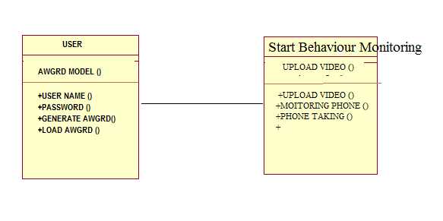

**4.3.2 USE CASE DIAGRAMS**

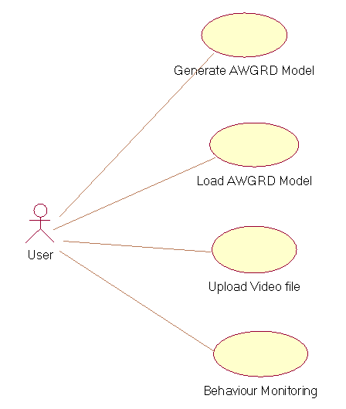

**4.3.3 SEQUANCE DIAGRAMS**

Fig 4.3.3:sequence diagrams

CHAPTER 5

SCREEN SHOTS & CONCLUSION & & REFERENCES

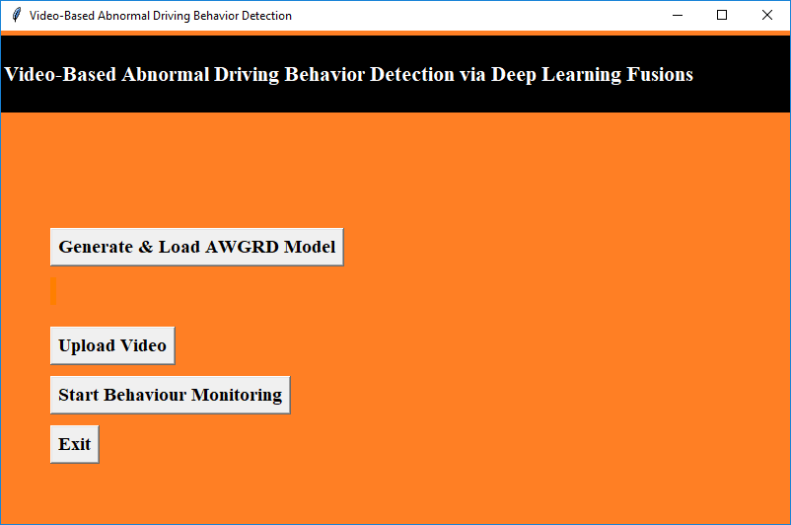

In above screen click on ‘Generate & Load AWGRD Model’ button to generate AWGRD train model. All model information we can see in black console after clicking on button

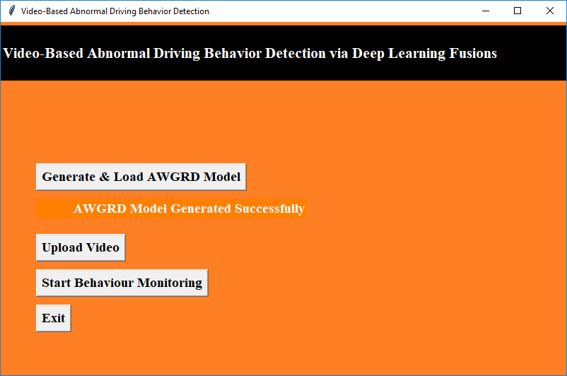

In above screen we can see model is generated and in below screen we can see all details

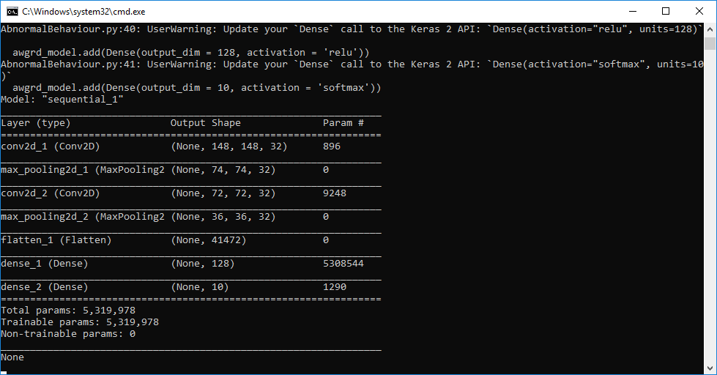

In above screen dense model using AWGRD is created. Now click on ‘Upload Video’ button to upload video

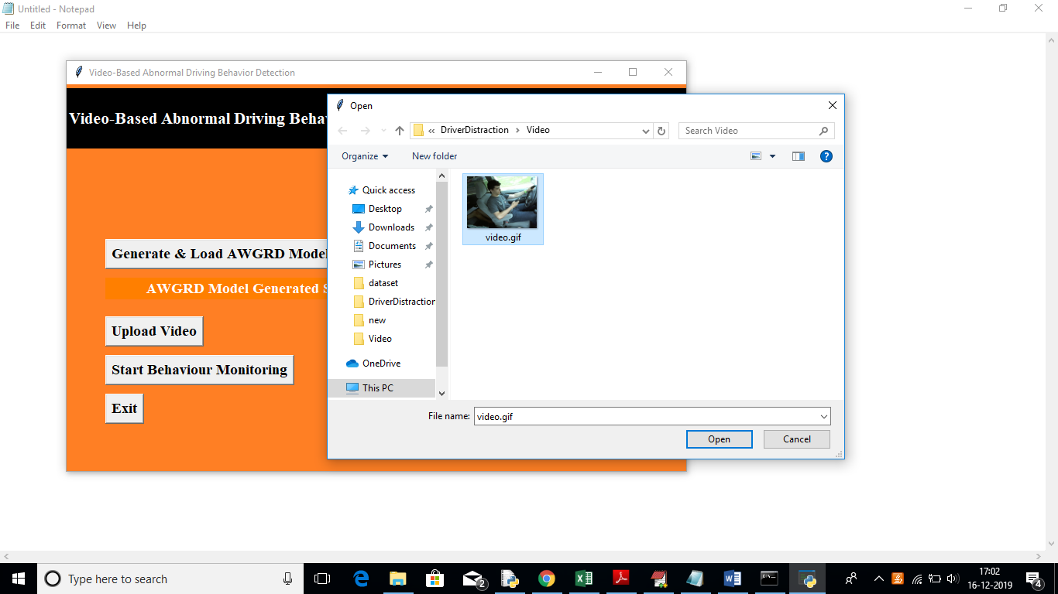

In above screen uploading one video and then click on open button and then click on ‘Start Behaviour Monitoring’ button

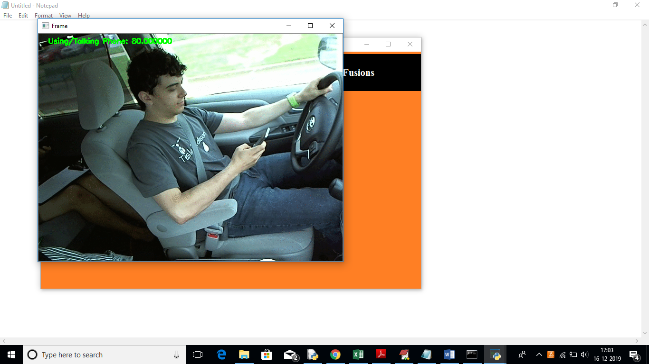

In above screen application detected user is using/talking on phone

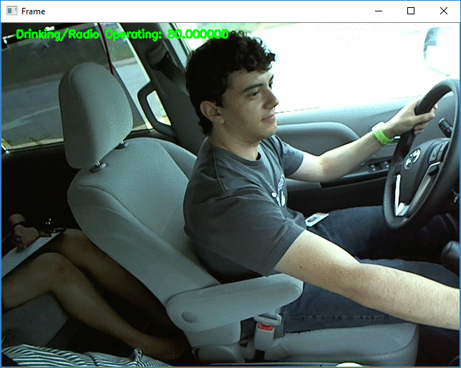

In above screen we can see user is try to start Radio. Similarly other detection will also be performed.

**CONCLUSION**

* The video-based abnormal driving behavior detection study is highly important nowadays, as it is a reliable and automatic manner to ensure safeties of drivers. Also, it receives vast popularity as it is an essential step to realize fully automatic driving (i.e., particularly in Level-3 and Level-4 stages according to the ‘‘autonomous driving’’ definition provided by the US Department of Transportation’s National Highway Traffic Safety Administration). In this study, three novel deep learning-based fusion models are introduced for the first time, to fulfill the video-based abnormal driving behavior detection task. Technically, these new models are inspired by the popular DenseNet, which was proposed in recent years. For WGD, it emphasizes on important issues of designs of modern deep learning models, including the depth, the width, and the cardinality. The width and the cardinality of WGD significantly increase, therein. For WGRD and AWGRD, they are more sophisticated as the important idea of residual networks with superpositions of previous layers is incorporated.

**FUTURE SCOPE :**

issues author has describe 3 algorithms based on CNN deep learning models.

1. Wide Group Densely (WGD) Network: Technically, WGD takes important issues of deep learning models, i.e., the depth, the width and the cardinality, into consideration when designing its model structure based on Dense Net. This model use deep features from input train model to get better prediction accuracy.
2. Wide Group Residual Densely (WGRD) Network: The most significant change of WGRD with respect to WGD is that, the idea of residual networks is incorporated in WGRD. In this algorithm input image will pass from one layer to other residual layer to have best features from train input image to get best accuracy.
3. Alternative Wide Group Residual Densely (AWGRD) Network: This algorithm works similar to above two algorithms but while passing input data from one layer to other, this algorithm will take super positions of previous layers which has best features from all layer and will have better prediction accuracy. Due to super positions extraction training efficiency will undoubtedly become higher.